1. Retail is currently experiencing an epic META-morphosis, driven largely by technological advances, innovation and the customers demand for personalised experiences across multiple brand touchpoints. In an ever-shifting retail landscape, in which experience replaces inventory, the customer is king. The advent of big data analytics has contributed much to the ability of firms to analyse the experiential elements that drive economic value.

Customer experience can be conceptualised as a customer’s ‘journey’ with a retailer over time, during the purchase cycle across multiple touchpoints. Select a fashion/apparel retailer or brand and critically evaluate a range of offline and/or online touchpoints. You must then use these insights to (re)design the end-to-end Customer Journey Map (CJM) in visual paradigm, illustrating how the customer experience can be enhanced by digital innovation, and applying the tenets of related theory. Use examples from fashion and related industries to support your answer.

(100 marks)

**SWOT**

**CURRENT OLIVER BONAS TOUCHPOINTS**

Oliver Bonas (OB) is a UK-based Lifestyle brand retailing women’s fashion, accessories, homeware and beauty both in-store and online. They primarily target millennial professionals aged between 25-44 (Sweeney, 2019). OB’s strong high street presence is the primary touchpoint through which consumers interact with the brand, with stores decorated to appear distinctive inside and out (see fig. 1, 2), in turn creating brand awareness and showcasing the “design-led” brand identity through retail environment and products (REFERENCE). OB avoids proximity to larger competitors when choosing store locations (REFERENCE), in turn limiting potential noise that could distort the message of uniqueness and quirkiness they are trying to convey to consumers. OB is on Klarna, Ebay, Zalando…

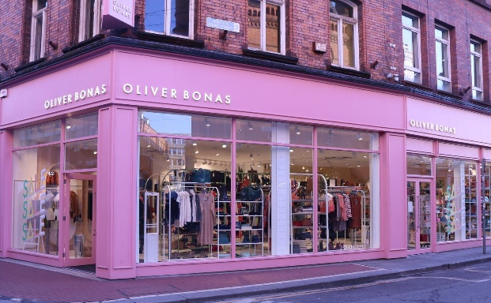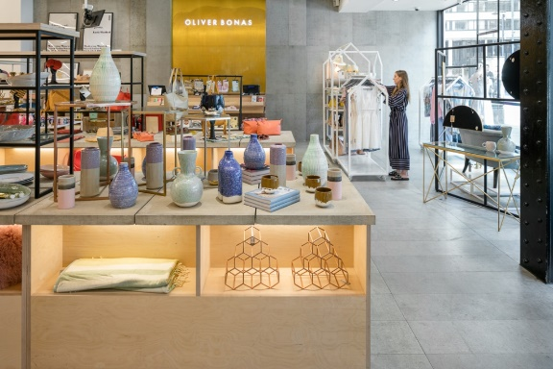

**Fig. 1** – OB storefront (left) and inside (right)

One-off in-store experiences, such as jewellery making or book binding workshops (Eventbrite, 2018). These form of ‘retailtainment’ are important touchpoints for OB consumers (Ritzer, 1999 REFERENCE). Experiences such as these drive economic value for OB as they improve brand image, generate brand buzz and cross-channel purchase intention (Jahn et al., 2018).

This strategy had proven successful for OB, experiencing year-on-year growth between 2008 and 2019 (Endole, 2021). However, the forced shuttering of store doors in 2020 because of the Covid-19 pandemic caused OB’s net worth to drop 13.15% from £8.5 million the year before to £7.4 million (Endole, 2021). OB responded to the growing demand for online shopping during this time by strengthening their e-commerce platforms. This was through improved personalisation of the online experience by using big data and machine learning to email tailored offers to consumers and provide more suitable search results on their website (Isaac, 2021). This e-commerce push boosted online sales by 55% in 2020 (Retail Week, 2022) enabling OB’s survival during the Covid-19 pandemic

However, OB’s utilisation of technology in consumer touchpoints is limited to their website and social media presence. While these channels communicate cohesive messages of brand identity (REFERENCE?), build consumer trust through personalisation (REFERENCE), and facilitate product purchase, improving innovation in the use of digital marketing strategies would better contribute to a sustainable competitive advantage. Since the post-covid re-opening of businesses, footfall and in-store purchases have increased, though not to pre-covid levels (REFERENCE). Shopping is increasingly a multi-channel experience, with consumers often interacting with multiple touchpoints before purchasing a product (REFERENCE). With product purchase increasingly taking place through online sales (REFERENCE), the role of retail stores must evolve to maintain creation of value for consumers despite the often-preferable convenience of online shopping. This is particularly important for OB where retail store footfall is so important for communicating their brand identity.

While OB strengthened their e-commerce capabilities, competitors showed greater levels of technological innovation. For example, in 2020 Zara launched *Store Mode*, an added functionality for their app and website which allows customers to check UK stores for inventory ability in real time, purchase items for click & collect, book fitting rooms, and use geolocation to find items in-store (Moran, 2021). Meanwhile, OB lacks an app for optimised m-commerce, and does not effectively utilise even more basic in-store or online digital marketing tools (such as chat bots on their website or kiosks in-store).

While OB’s target consumers regularly use e-commerce and m-commerce platforms, they still demand in-store experiences as it is a key creator of value for OB’s consumers. OB must innovate in their e-commerce and m-commerce channels and evolve the in-store environment to better support those channels, as well as offer in-store experiences to maintain footfall as online shopping becomes the norm for product purchase.

App

As an initial step to enhance customer experience, Oliver Bonas should create a smartphone application in order to integrate and further personalise the customer’s shopping experience. Most of Oliver Bonas’ competitors e.g. Anthropologie, Free People and John Lewis, already have apps and OB are hugely missing out without one. OB’s current consumers are mainly based in the UK which has the second highest percentage of mobile shoppers in Europe with 66.7% (Binns, 2021). Furthermore, increasing smartphone ownership has led to a huge rise in m-commerce and by 2023 4.3 billion people, well over half the earth’s current population, are expected to own a smartphone (Binns, 2021).

In the UK, during the peak of the pandemic, m-commerce rose 73% year-on-year and by 2024 UK m-commerce retail sales are expected to reach £105 billion (Binns, 2021). As well as increasing sales, an app would increase ease of shopping, enabling consumers to seamlessly move from instore touchpoints to desktop to mobile. It would also improve engagement, increase the speed of transactions, and reduce the number of abandoned carts (reference).

The app could include…

Kiosks

The introduction of interactive kiosks instore would be an ideal next step for OB as they have become so common and accepted, like mobile apps, they wouldn’t put off consumers who are less confident with digital devices. Furthermore, OB customers enjoy visiting the stores in person as they are a pleasant environment etc etc so kiosks would be good. The kiosks would allow customers to log into their OB account, browse products, check stock availability, process payments and order online. This would reduce costs for OB and allow the capture of customer data but also greatly decrease queuing times for customers, which can often be very off-putting for customers, particularly around busy periods like Christmas.

The kiosks would also support the success of ‘Quiet Time’ a new initiative OB have created in order to make sure their brand promise of making living a joyful experience and give cause for optimism is inclusive for all customers (Oliver Bonas, 2022). During Quiet Time, there is no music, reduced background noise, dimmed lighting, and employees do not approach customers, to allow people with sensory issues to shop in a peaceful environment. Interactive kiosks would make Quiet Time more viable as they would allow customers to find out what they need or even complete a purchase, without having to ask a sales associate and disturb the quiet. It would also benefit the growing number of consumers who just prefer self-service to human interaction.

AR Furniture and Fashion

Wrapping robots

Workshop planning informed by Big Data – Retail–tainment

As previously mentioned, OB greatly benefit from their one-off instore experiences so an obvious next step would be to use technology and big data in order to improve and personalise these experiences for customers.

App

AR Furniture and Garments – The impact of experiential augmented reality applications on fashion purchase intention

Kiosks

Wrapping robots

Workshops utilising big data to personalise

Highlight when data is collected

Clothing size estimator

It is recommended that the OB app have a clothing size estimator (CSE). CSEs such as those offered by Fit Analytics utilise purchase, return and fit data to inform machine learning algorithms that predict customer garment size from their input physical traits. CSE implementation has been shown to boost sales conversion and reduce returns (Fit Analytics, 2022), in turn driving economic through increased sales and reduced logistical burden.

**References**

Eventbrite. 2018. *Oliver Bonas - Manchester Workshop Series*. [online] Available at: <https://www.eventbrite.co.uk/e/oliver-bonas-manchester-workshop-series-tickets-46402844156?utm_source=facebook&utm_medium=social&utm_campaign=fbpost24.05.18manchesterevents&rmatt=tsid:1043416> [Accessed 27 January 2022].

Jahn, S., Nierobisch, T., Toporowski, W. and Dannewald, T., 2018. Selling the extraordinary in experiential retail stores. *Journal of the Association for Consumer Research*, *3*(3), pp.412-424.

Sweeney, T., 2019. First look: Oliver Bonas Dublin. 'The busiest opening we've ever had'. *The Irish Times*, [online] Available at: <https://www.irishtimes.com/life-and-style/fashion/first-look-oliver-bonas-dublin-the-busiest-opening-we-ve-ever-had-1.4089627> .

Endole. 2021. *Endole - Oliver Bonas*. [online] Available at: <https://suite.endole.co.uk/insight/company/03799350-oliver-bonas-limited>].

Isaac, S., 2021. *Personalisation in conversation with Camilla Tress at Oliver Bonas*. [online] Internet Retailing. Available at: <https://internetretailing.net/customer/customer/personalisation-in-conversation-with-camilla-tress-at-oliver-bonas-23141> [Accessed 27 January 2022].

Retail Week. 2022. *Oliver Bonas - Overview*. [online] Available at: <https://www.retail-week.com/prospect/oliver-bonas/117.supplier> [Accessed 27 January 2022].

Moran, G., 2021. *Zara launches Store Mode technology in UK*. [online] Drapers. Available at: <https://www.drapersonline.com/news/zara-launches-store-mode-technology-in-uk> [Accessed 27 January 2022].

Fit Analytics. 2022. *Fit Analytics | Apparel's Machine Learning Platform*. [online] Available at: <https://www.fitanalytics.com/> [Accessed 27 January 2022].